RCD Snubber Design for Flyback

Leakage inductance is added:

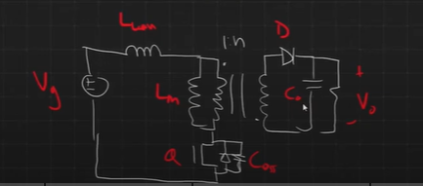

What we were looking at was the specific transition: what happens when we turn off the switch?

Let the voltage across the switch be VQ.

Right after the switching transition when we're considering DCM only, there's an oscillation between the magnetizing inductance and the output capacitance it's slower than the oscillation that occurs with the leakage inductance and the output capacitance.

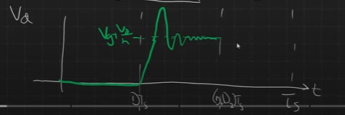

As it can be seen above Figure, in the first interval the transistor is on. Assuming that it has mostly zero voltage, when we turn off the switch this output capacitor is not yet charged. It takes some time for that voltage to rise up. Eventually, it reaches to a voltage of Vg + Vout /n leading to reduce the magnetizing inductance and causing oscillations in the leakage inductance with the output capacitance of the switch until the energy dissipates. This dissipated leakage energy and power can be described as follows:

$$E_{leakage}=\frac{1}{2}L_{leak}i_{peak}^{2}→ P_{leakage}=\frac{1}{2}L_{leak}i_{peak}^{2}f_{sw}$$

 This dissipated power can be dangerous for the circuit and the main aim to insert the snubber circuit to rectify that.

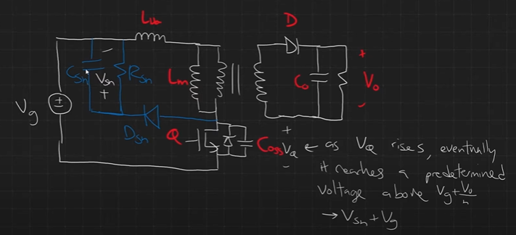

*RCD implementation to Flyback*

How does RCD prevent the oscillation?

As vq, the voltage across the output across the switch rises eventually it reaches a predetermined voltage, a voltage that we design, above Vg + Vout/n.

with this snubber VQ  to rise until it reaches to a predetermined voltage above Vg + Vout/n namely, Vsn + Vg.

As the voltage across the snubber capacitor is called as Vsn, what it’s aim is actually acting a voltage source and preventing the voltage on this switch from rising above Vsn + Vg. Overall, the energy stored in the leakage inductance flows through the diode right at some point and flows back into the capacitor. At the point, it was noticed that the snubber capacitor should be large enough so that even by this inductance interaction, its voltage stays constant near Vsn.

Then when the snubber diode is off meaning that when the specified voltage right below Vsn + Vg then the stored energy in snubber capacitor Csn can be dissipated through Rsn. By snubber diode, the voltage across the switch is held at Vsn + Vg level.

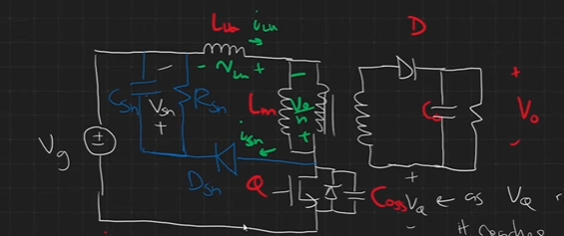

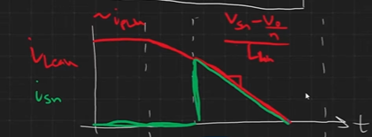

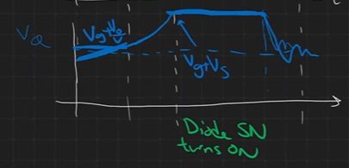

Snubber Waveforms (Leakage and snubber current, and switch voltage)

**Chossing Rsn, Csn and Vsn**

Knowing that the average current should be zero across the Csn for steady state as its average voltage is desired to be roughly constant. Thus, the sum of average current that flowing through capacitor is zero.

$$〈i_{Csn}〉= {〈i_{diode}〉}_{Ts}-\frac{V_{sn}}{R_{sn}}=0$$

To find average diode current:

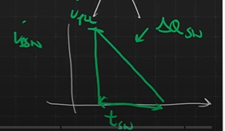

Zoom in version of diode current in snubber time over a full period

At this stage an approximation can be made for the peak current. It is assumed that the leakage peak current is accepted in a fully-charged mode. So for CCM operation,

$$i_{peak}=I_{Lm}+ {∆i}_{Lm}$$

The slope of the snubber current above Figure can be found as well since the snubber is activated the voltage applied to the leakage inductance becomes

$$\frac{V_{sn}-\frac{V_{o}}{n}}{L_{leakage}}$$

So the average snubber charge $∆Q_{sn}$, becomes the triangular area:

$$∆Q_{sn}=\frac{1}{2}t_{sn}i_{peak} as t_{sn} is the time it takes for the current to be fully discharged$$

By using slope ratio,

$$i_{peak}=\frac{V_{sn}-\frac{V_{o}}{n}}{L_{leakage}}t_{sn} → t_{sn}=\frac{i_{peak}L_{leakage}}{V_{sn}-\frac{V_{o}}{n}}$$

Inserting this $t_{sn}$ and knowing also that $i_{D_{sn}}=\frac{∆Q_{sn}}{t_{sn}}= ∆Q_{sn}f_{sw}$ we obtain that

$$i_{D_{sn}}=\frac{1}{2}i_{peak}^{2}L_{leakage}f_{sw}\frac{1}{V_{sn}-\frac{V_{o}}{n}}$$

As knowing also

$$〈i_{Csn}〉= {〈i_{diode}〉}_{Ts}-\frac{V_{sn}}{R_{sn}}=0$$

$$i_{peak}^{2}L_{leakage}f_{sw}\frac{1}{V_{sn}-\frac{V_{o}}{n}}= \frac{V_{sn}}{R_{sn}}$$

Vsn is a chosen value by the team, meaning that the voltage level the switch should be able to be exposed is considered while choosing Vsn. Learning that it usually is chosen as 50 V higher thatn Vg + Vout/n,

$$V_{sn}=$$

By solving the last equation for Rsn

For Csn,

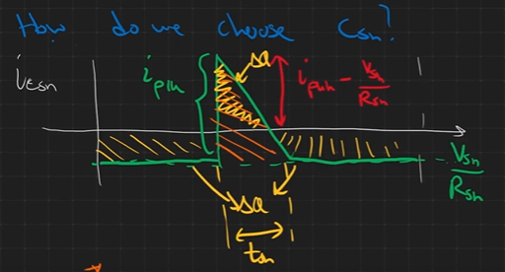

For every period, when the snubber diode is on, the current is increased to charge the capacitor, then eventually being equal to the diode current. When the diode is off, it is equal to the current that passes through the snubber resistor as magnitude. Overall, a triangle occurs for each cycle. The larger triangle area is equal to

$$∆Q^{*}=\frac{1}{2}i_{peak}t_{sn}$$

And smaller triangle area similarly becomes by triangle ratio,

$$\frac{{\left(i_{peak}-\frac{V_{sn}}{R_{sn}}\right)}^{2}}{i_{peak}}∆Q^{*}=\frac{{\left(i_{peak}-\frac{V_{sn}}{R_{sn}}\right)}^{2}}{i_{peak}}\frac{1}{2}i_{peak}t_{sn}$$

A simple equation is obtained by assuming that either snubber time tsn or Vsn/Rsn is small enough. Then we can get that

$$∆Q=\frac{1}{2}i_{peak}t_{sn} or ∆Q= \frac{V_{sn}}{R_{sn}}(T_{s}-t_{sn})$$

Since $∆Q=C∆V$,

$$C_{sn}=\frac{∆Q}{{∆V}_{sn}}=\frac{\frac{1}{2}i_{peak}t_{sn} }{{∆V}_{sn}}$$

Selecting the ripple rating as (1-5)..%.

$$C_{sn}=$$